JCM OSCE PWH 11/2016

Question 1

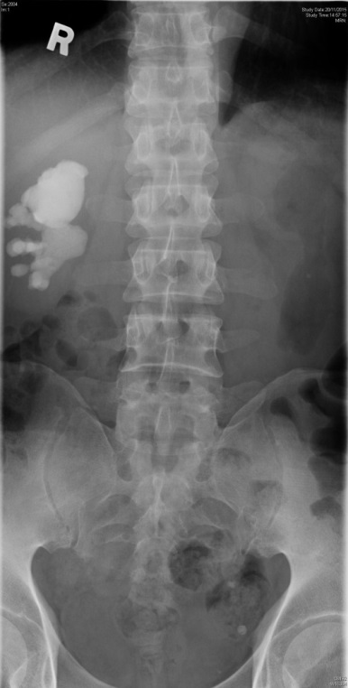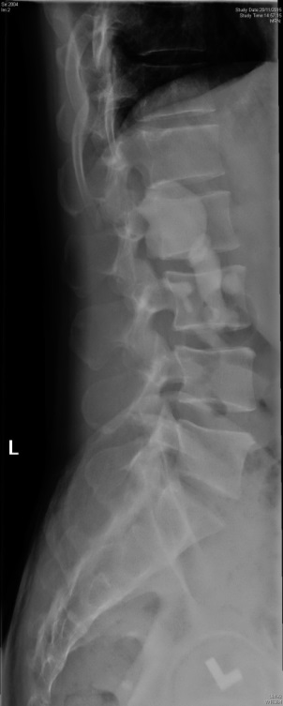
49 years old gentleman presented with low back pain for 6 months. He has no history of injury. He denied urinary and gastro-intestinal symptoms. X-ray LS spine was performed

- Describe the X-ray. What is the diagnosis
______________________________________________________________________________________________________________________________________________________________________________________________

- What are the commonest components of the stone?
______________________________________________________________________________________________________________________________________________________________

- Name the associated common organism for the formation of stone
______________________________________________________________________________________________________________________________________________________________

4 What is the best definitive treatment?
____________________________________________________________________________________________________________________________________________________________________________________________

5 What is the long term complication if the stone is left untreated?
____________________________________________________________________________________________________________________________________________________________________________________________

Question 2

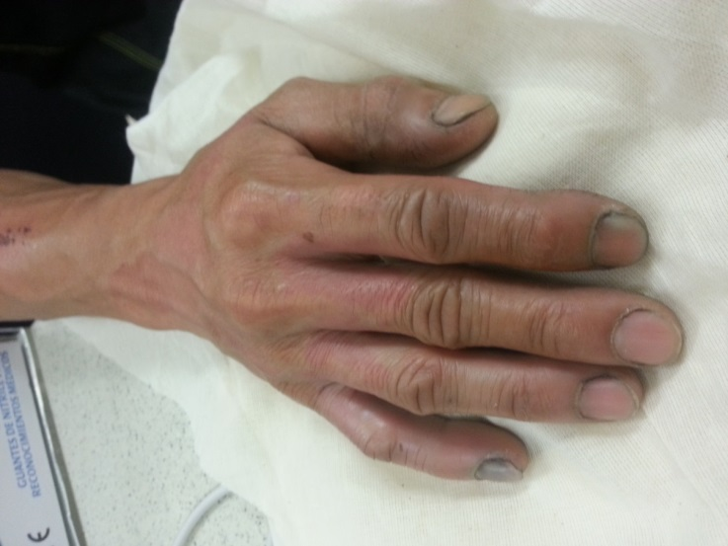

53 years old cleaner worker complained of right intense deep burning hand pain at the midnight. He cleaned the swimming pool in the morning. The patient is fully conscious with stable vital sign.

- Describe the picture
______________________________________________________________________________________________________________________________________________________________________________________________

- What is the suspected culprit?
_______________________________________________________________________________________________

- What is the mechanism of the injury?
______________________________________________________________________________________________________________________________________________________________________________________________

- What are the life threatening complications?
_____________________________________________________________________________________________________________________________________________________________________________________________________________________________________________

- What are the treatment options?
_____________________________________________________________________________________________________________________________________________________________________________________________________________________________________________________________________________________________

Question 3

45 year old man was bitten by a snake at home 30 minutes ago. He came to A&E with the snake.
Blood pressure was 145/85, Pulse was 90bpm, SpO₂ was 99%. RR was 16.

On examination, the patient was not in distress. There was fang mark over the right hand.
There was no gross swelling / bruising.
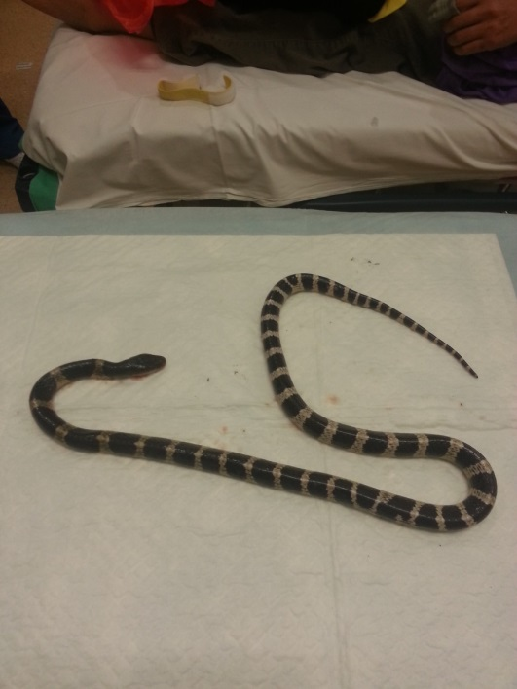

- Describe the snake. What is the common name of this snake?
______________________________________________________________________________________________________________________________________________________________________________________________

- What is the toxin? What kind of toxicity would you anticipate?
______________________________________________________________________________________________________________________________________________________________

- List 2 initial symptoms / physical signs that you will look for, in order to watch out for deterioration?
_____________________________________________________________________________________________________________________________________________________________________________________________________________________________________________________________________________________________

- What antivenom will you consider? Will you consider give anti-venom if the patient does not have any symptom? Why?
_____________________________________________________________________________________________________________________________________________________________________________________________________________________________________________________________________________________________

- List 1 important complication in giving the treatment you suggested?
Suggest 2 pretreatments to reduce the risk of such complication.
_____________________________________________________________________________________________________________________________________________________________________________________________________________________________________________________________________________________________

- The Pharmacy told you that the treatment you suggested was not immediately available and the patient developed ptosis in A&E, what medical treatment that can be helpful in order to buy time?

_____________________________________________________________________________________________________________________________________________________________________________________________________________________________________________________________________________________________

Question 4

33 years old female, unremarkable past health, underwent IVF and had embryo transfer 10 days ago.
She complained of abdominal distension and SOB for 2 days.
Ultrasound images were obtained (Right coronal scans)

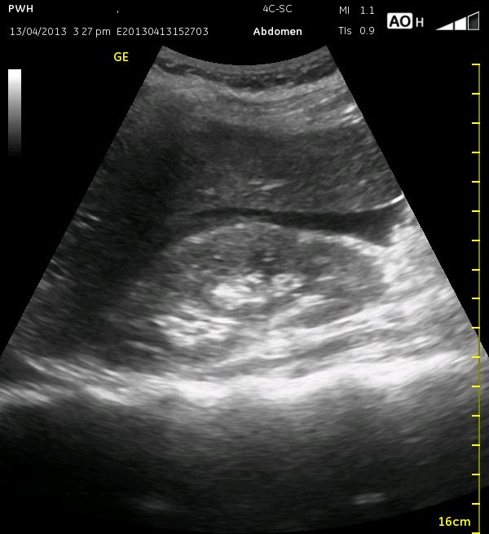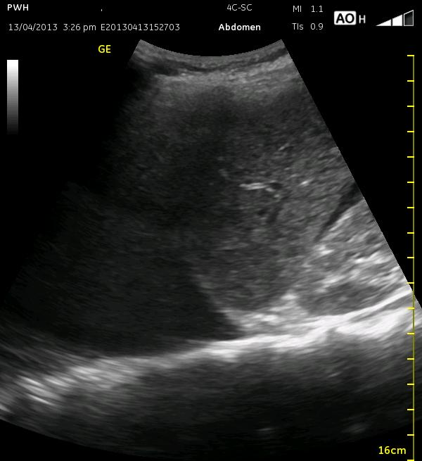

- Describe the ultrasound findings?
_______________________________________________________________________________________________

- What would be the expected ultrasonic finding(s) of the ovaries in this patient?
____________________________________________________________________________________________________________________________________________

- What is the most likely diagnosis?
______________________________________________________________________

- Name 3 risk factors of the disease
______________________________________________________________________
______________________________________________________________________

- Can you describe the pathophysiology leading to the diagnosis you mentioned in Q3 ?
______________________________________________________________________
______________________________________________________________________

- Why is pelvic examination contraindicated in this patient?
______________________________________________________________________
______________________________________________________________________

- List 3 complications of the disease
______________________________________________________________________
______________________________________________________________________
Question 5

50 years old gentlemen presented to A&E for sore throat and fever for 2 day.
He complained of odynophagia. Denied history of foreign body ingestion
P/E
Temp 38.2
Swelling over the neck and mandible
BP 165/67 P 122 SpO2 96% RA
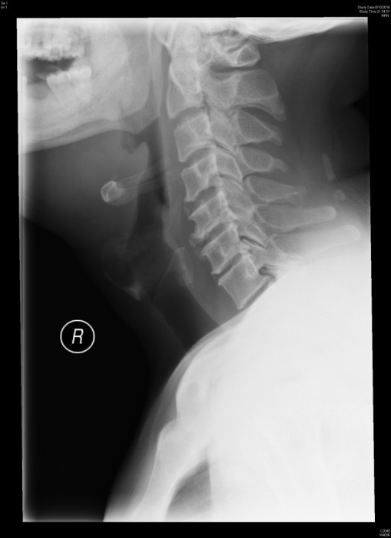
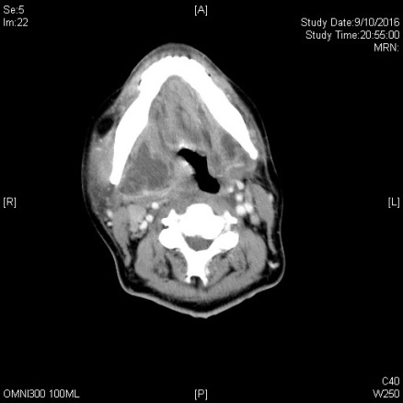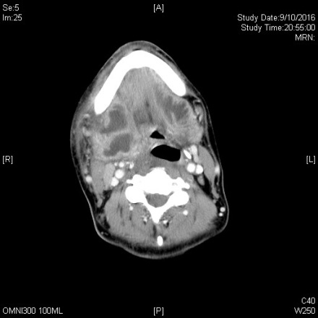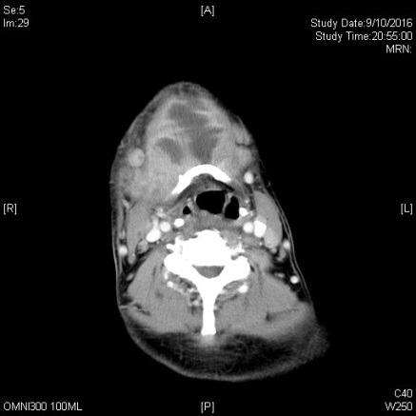

1 Describe the X-ray and CT scan
___________________________________________________________________________________________________________________________________________________________________________________________

2. What is your clinical diagnosis? List 3 ddx
___________________________________________________________________________________________________________________________________________________________________________________________

- What are the 3 anatomical space involved?
_______________________________________________________________________________

- What is the most frequent source of infection? List 2 more
______________________________________________________________________________________________________________________________________________________________

- List 3 commonest organism involved
______________________________________________________________________________________________________________________________________________________________

- What are the high risk groups?
______________________________________________________________________________________________________________________________________________________________

- List 3 complications
______________________________________________________________________________________________________________________________________________________________

- What is the Lemierre syndrome?
______________________________________________________________________________________________________________________________________________________________

Question 6
61years old, chronic drinker, complained of sudden onset of chest pain, radiated to back. The pain was associated with sweating and vomiting.
BP L 90/65 R 89/62 P 120 SpO2 96% 2L
ECG showed sinus tachycardia

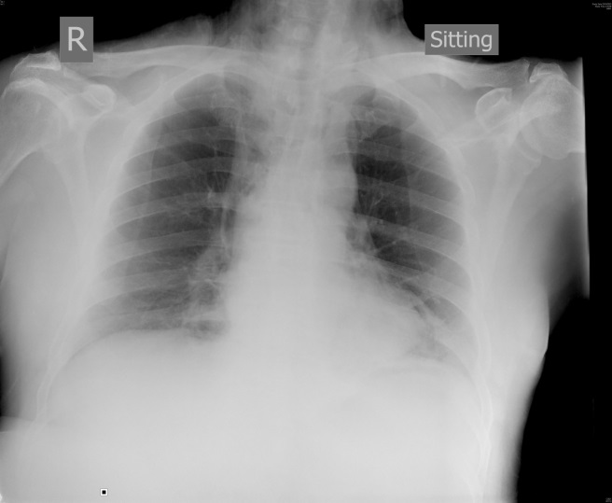

- Describe the CXR:
______________________________________________________________________________________________________________________________________________________________

- What is your working diagnosis? What is the name of classical triad?
______________________________________________________________________________________________________________________________________________________________

Urgent contrast CT thorax was ordered.
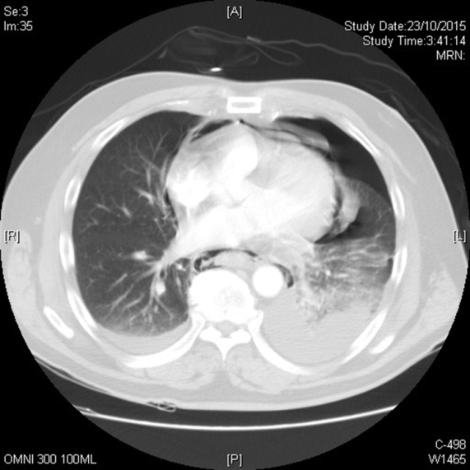

- Describe the CT
___________________________________________________________________________________________________________________________________________________________________________________________

- What is the A&E management?
______________________________________________________________________________________________________________________________________________________________

